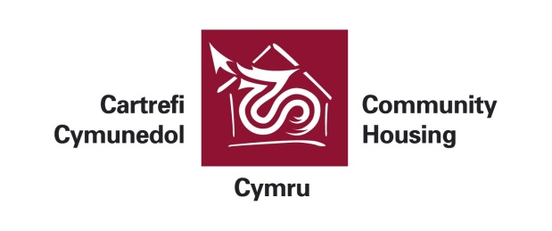
a t t e n d a n c e
MEETING | N497 Housing-led Regeneration Network
DATE | 30/01/2015 10:00:00
VENUE | Media Resource Centre

Name | Organisation | Contact Jobtitle
Andrew Jones | Charter Housing Association Ltd | Projects & Partnerships Manager
Clare Watkins | Coastal Housing Group | Employability and Skills Manager
David Tovey | Coastal Housing Group | Supported Housing Strategic Manager
Emma Denyer | Coastal Housing Group | Adapt Assistant
Hayley MacNamara | Community Housing Cymru | Regeneration Officer
Jayne Regan | Hafan Cymru - Carmarthen | Training Services Manager
Kristin Vaughan | Wales & West Housing | Employment and Enterprise Coach
Lee Jones | Merthyr Tydfil HA | Tenant & Community Development Manager
Liz Barnett | The Green Valleys | Community Projects Support Officer
Marc Fury | Newport City Homes | Regeneration Manager
Mark Sheridan | Taff HA Ltd | Director of Support Services
Max Cahn | Coastal Housing Group | Area Housing Manager
Naomi Mitcheson | Derwen Cymru | Housing Manager
Nicole Barnes | NPT Homes | Community Regeneration Co-ordinator
Paula Lunnon | Merthyr Valleys Homes | Community Development Team Leader
Phil Richardson | Cadwyn HA | Supported Housing Manager
Rachel Honey-Jones | NPT Homes | Community Development Officer
Rachel Morton | Valleys to Coast Housing Ltd | Community Regeneration Officer
Sam Howells | Charter Housing Association Ltd
Samantha Reed | Newport City Homes | Community Initiative Co-ordinator
Sarah Bennett | Coastal Housing Group | Head of Housing Services
Shelagh Iles | Rhondda HA | Director of Community Regeneration and Support
Simone Devinett | Rhondda HA | Find Your Future Co-ordinator
Steve Cranston | United Welsh | Head of Community Investment
Thomas Davies | Valleys to Coast Housing Ltd | Business Apprentice
Nia Griffiths | CREW | Director

