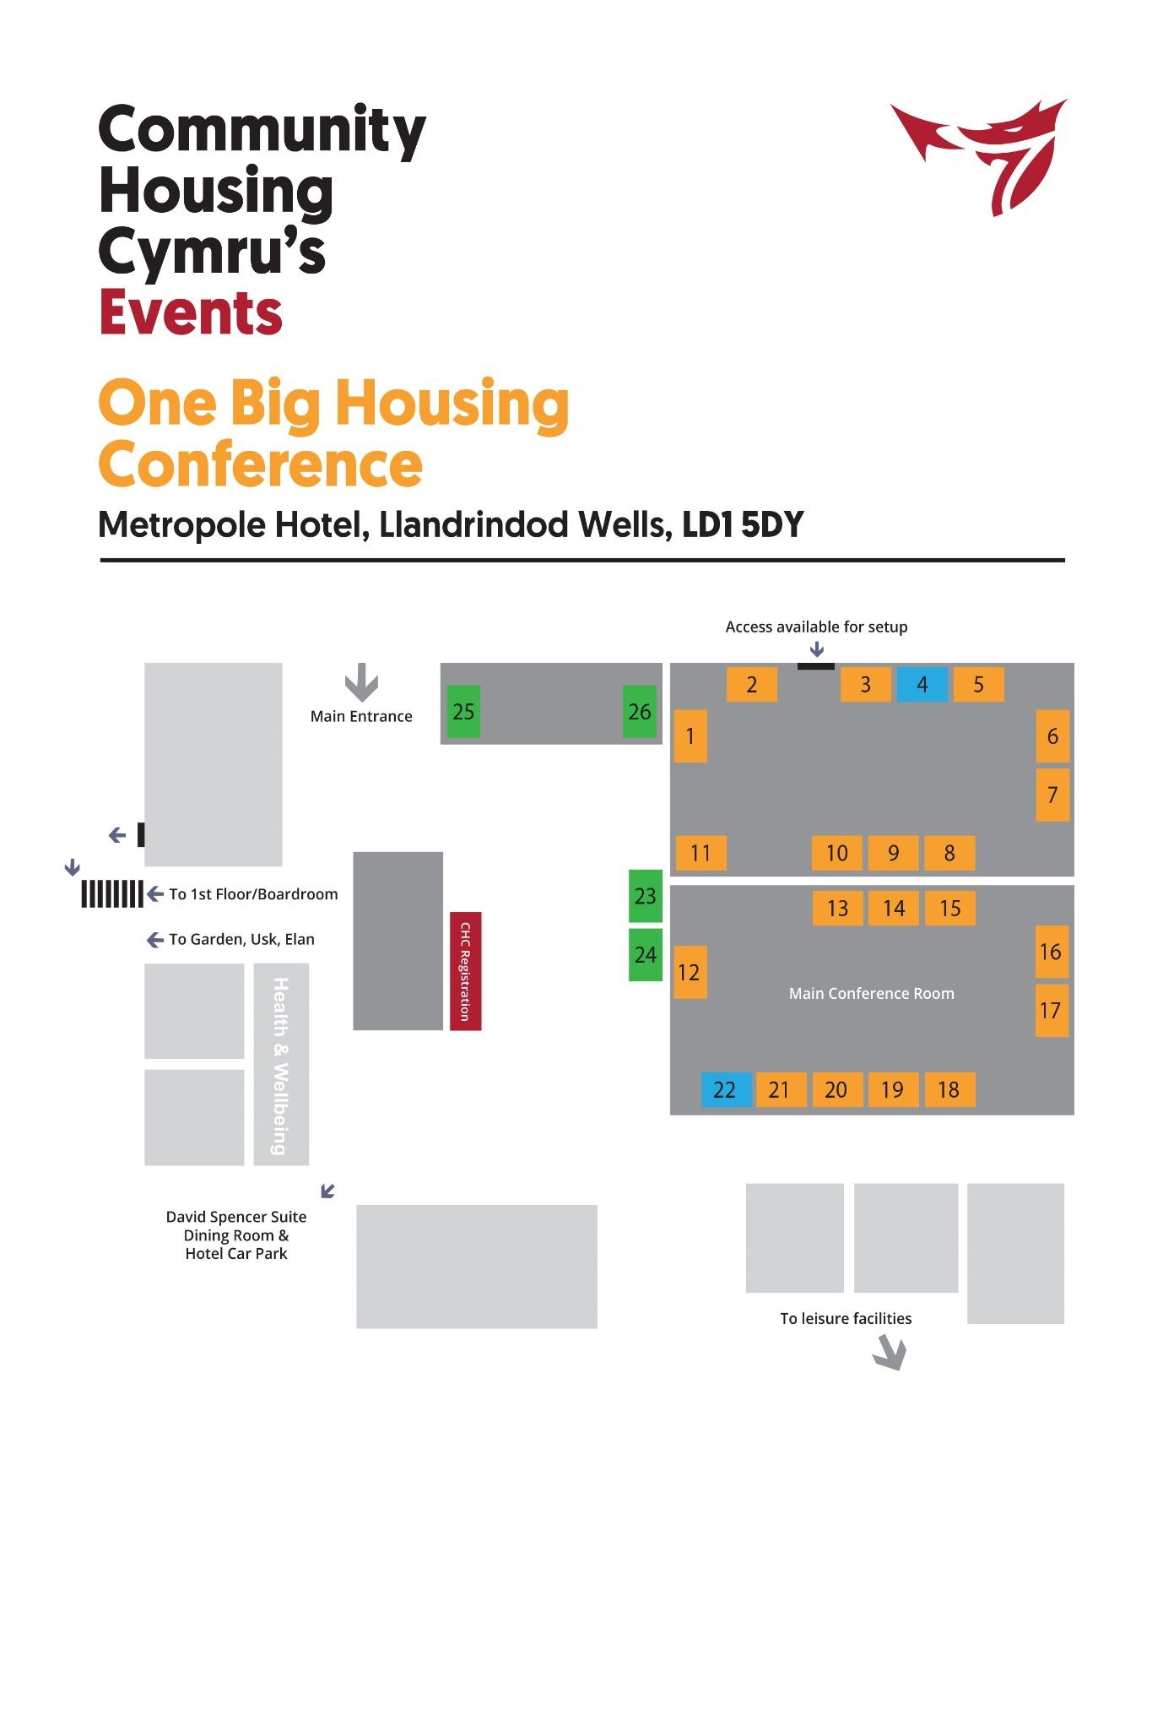

Stand 1: Warm Wales and Wales & West Utilities 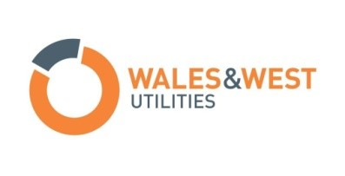
At Wales & West Utilities, we do our best to keep our 7.5 million customers safe and warm, with a gas supply they can rely on and a level of service they can trust.
We don’t sell gas; instead we use our network to transport gas to homes and businesses throughout Wales and South West England. We maintain our network, connect new properties and respond to gas emergencies.
Partnering with Integrated Energy Services helps us tackle key issues affecting communities we serve, including the ability to keep warm at a reasonable cost and look after our customers most in need.
Contact details:
Jonathan Cosson  Projects Director, Warm Wales  01656 747614  marketing@warmwales.org.uk  www.warmwales.org.uk | Stuart Neill  Network Extensions Manager, Wales & West Utilities Ltd  Network Extensions Manager  Tel: 02920 278713  stuart.Neill@wwutilities.co.uk  www.wwutilities.co.uk

Stand 2: Parex
Parex is a European leader in Renders and External Wall Insulation (EWI) solutions for retro-fit and new build.
The company’s portfolio includes a complete range of through-coloured mineral and acrylic renders together with a wide range of base coats, specialist renders and accessories. It also offers a range of dash products and insulated brick slip systems .
PAREXTHERM systems are suitable for any insulation type, any substrate, available in any colour and can be used to create any finish.
PAREXDIRECT systems offer a range of unique solutions featuring traditional mineral or advanced acrylic renders for non-insulated facades.
Widely used for refurbishment of housing stock in Wales, many products and systems in the range hold BBA, IAB, LABC and European approvals.
Contact details:
Phone: 01827 711 755
Abeles Way, Holly Lane Industrial Estate, Atherstone, Warwicks, CV9 711 755
@parexuk
www.parex.co.uk

Stand 3: Expedite Project Services
Established in 2013, and although new to the market, EXPEDITE focus solely on providing a Director-led Project Management Service throughout the UK for respected clients, delivered from our offices in Cardiff, Bristol, Exeter and London.
Our in-house experts collaborate with a handpicked team of industry specialists and partners to maximise your investment and achieve your objectives at every stage.
Whether your project is a new build development, renovation of an existing site or the restoration of a listed building, EXPEDITE will make it happen – from first conceptto final delivery.
Our technical ability and experience ensure delivery of a professional but fresh solution to ensure your requirements are achieved. This approach allows the client to focus on its own day-to-day requirements in the knowledge that their project will be delivered effectively, professional and to the standards expected.
EXPEDITE and its’ staff have an impressive record of delivering exemplar projects, effectively working across all construction disciplines. We are therefore fully conversant with all aspects of PM disciplines and can adapt to client specific requirements with ease.
Contact details:
Phone: 02920 098 655
8, Village Way, Greenmeadow Springs Business Park, Cardiff, CF15 7NE
@Expediteps
www.expediteps.com

Stand 4: Robert Price Builders Merchants
Robert Price is the largest independent builders’ merchants in South Wales. With 22 branches across the region, we are sure to have a branch near you.
Since 1847, Robert Price has been providing outstanding service and high-quality products to local tradesmen and public sector organisations, as well as self-builders and DIY enthusiasts. With over 20,000 products available from leading manufacturers, Robert Price have everything you need to make your project a success
Contact details:
hone: 01633 636163
Old Compton Place, Corporation Road, Newport, NP19 4AD
@RobertPriceBM
www.robert-price.co.uk

Stand 5: Wilko Retail
Wilko is a high street retailer that is focused on providing value for money products along with great customer service. Wilko now offers a secure decorating allowance solution in the form of the Wilko Decorating Card for the social housing market. This card is aimed at the Housing provider and Maintenance Contractors where tenants are provided with a self decorating allowance. The card allows the tenant to purchase all of there decorating essentials from our extensive decorating ranges, available from over 400 stores across the country.
Contact details:
Phone: 01909 505 739
JK House, Roebuck Way, Manton Wood, Worksop, Notts, S80 3EG
@LoveWilko
www.wilko.com
Stand 6: Kier Living
Kier Living is one of the UK’s largest regional house builders. Part of the Kier Group, Kier Living is able to offer partners in development a complete solutions to tailor their needs and aspirations for sites identified for residential development. Our understanding and experience is built over 70 years of delivering quality homes and communities within the residential sector. Being part of one of the UK’s largest construction companies means that Kier Living can offer industry recognised expertise in providing residential solutions that encompass a consideration of the complete development process.
Kier Living offers a regionalised structure. Supported by resources nationally, our local offices are able to provide the necessary local context to our relationships and solutions. Kier Living understands the needs of partners and communities locally, providing our clients’ with the reassurance that our approach places the local community at its heart.
Kier Living currently builds over 2,150 homes each year. We are working hard towards a target of over 3,600 homes annually by 2020.
Contact details:
Phone: 0121 713 6300
Kier Living Ltd I Tungsten Building, Central Boulevard, Blythe Valley Park, Solihull, West Midlands, B90 8AU
@kiergroup ‏
www.kier.co.uk

Stand 7: Dimplex
Whilst Dimplex has the UK’s largest range of electric heating solutions, it offers unrivalled pre and post installation support, together with vast experience in the social housing sector.
Its revolutionary Quantum off-peak heater is up to 27% cheaper to run than a standard storage heater system. Easy to install, easy to use and offers heat on demand – night and day.
Contact details:
Phone: 01489 773000
Millbrook House, Grange Drive, Hedge End, Southampton SO30 2DF
@DimplexUK
www.dimplex.co.uk

Stand 8: TriPartum Limited
TriPartum are knowledgeable and experienced customer communications management (CCM) experts. Our seamlessly integrated Managed Service – which includes in-depth business and document analysis, the highest standards of design creativity and deep technology knowledge – enables clients to enhance the customer experience and journey whilst maximising return on investment in communications processes.
Our experience spans a wide range of sectors including Insurance, Telecom, Utility, Retail and Financial Services which enables us to bring fresh thinking to Housing Associations customer communications not only with paper but aligning with your ‘Digital Transition’ strategy as we deliver to multiple-channels today
Contact details:
Phone: 0207 186 0052
12 Gateway 1000, Arlington Business Park, Whittle Way, Stevenage, SG1 2FP
@TriPartum
www.tripartum.com

Stand 9: Contour Showers
With over 55 years’ experience, Contour Showers are a leading UK manufacturer of easy access shower trays with exclusive Biomaster antibacterial protection, half height shower doors and shower waste pumps, all of which enhance the independent lifestyle.
Our latest products, the allNEW ShowerDec® wetroom floor former, 360° door hinge system and P12 shower waste pump using a variable speed controller will be available for demonstration at Stand 9 to help you learn how we can help you in the adaptation process.
Contact details:
Phone: 01606 592586
Siddorn St, Winsford CW7 2BA
www.contour-showers.co.uk

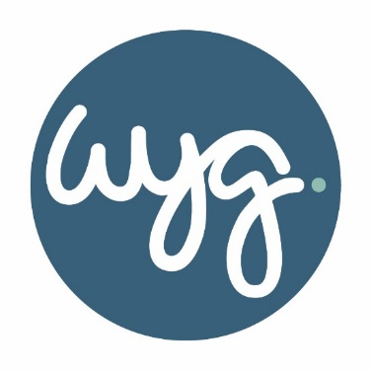
Stand 10: WYG
WYG provide a high quality, responsive, national service to a diverse range of clients in both the public and private sectors. Based in seventeen offices across the UK, including Cardiff, we are one of the top three planning consultancies in the UK (source: LondonStockExchange 06 Jan 2016).
We offer core town planning, environmental, transportation, master planning, urban design, project management and engineering services, as well as niche services in specialist areas such as acoustics, archaeology, asbestos, ecology, landscape architecture, minerals and waste.
Contact details:
Phone: 029 2032 0789
5th Floor, Longcross Court, 47, Newport Road, Cardiff
@wyggroup
www.wyg.com

Stand 11: HR Timber Frame
Established in 2013, and although new to the market, EXPEDITE focus solely on providing a Director-led Project Management Service throughout the UK for respected clients, delivered from our offices in Cardiff, Bristol, Exeter and London.
Our in-house experts collaborate with a handpicked team of industry specialists and partners to maximise your investment and achieve your objectives at every stage.
Whether your project is a new build development, renovation of an existing site or the restoration of a listed building, EXPEDITE will make it happen – from first conceptto final delivery.
Our technical ability and experience ensure delivery of a professional but fresh solution to ensure your requirements are achieved. This approach allows the client to focus on its own day-to-day requirements in the knowledge that their project will be delivered effectively, professional and to the standards expected.
EXPEDITE and its’ staff have an impressive record of delivering exemplar projects, effectively working across all construction disciplines. We are therefore fully conversant with all aspects of PM disciplines and can adapt to client specific requirements with ease
Contact details:
Phone: 01685 666 111
Unit 3 & 4 Cyfarthfa Industrial Park, Merthyr Tydfil CF48 1BS
http://www.hrtimberframe.co.uk/

Stand 12: Utilita
Utilita Energy is the leading supplier of Smart Pay As You Go Energy in Great Britain - offering a simple, user-friendly and competitively priced PAYG service to lower income and energy conscious households via the installation of free, market-leading smart meters. Every customer is able to top-up their energy remotely, any time, any place, as well as monitor their usage and spend in real-time. Whether for students, landlords, letting agents, social housing or as a low cost-to-serve energy solution for new builds - our Smart Pay As You Go service has huge benefits for everyone
Contact details:
Phone: 0345 207 2000
Hutwood Court, Bournemouth Road, Chandler's Ford, Eastleigh, SO53 3QB
@UtilitaEnergy
www.utulitaenergy.co.uk

Stand 13: Nuaire
Nuaire is a UK manufacturer and market leader providing ventilation solutions for high indoor air quality. Poor ventilation can lead to several problems for Social Housing providers, including condensation and mould growth, radon gas and poor indoor air quality for tenants.
Today we remain at the forefront of domestic ventilation technology, with a range of products that solve the challenges faced by both house developers and home owners. From meeting building regulations to meeting short lead times we deliver on product, price and service. Nuaire is committed to the principals of energy-reduction, heat recovery and renewable product innovation
Contact details:
Phone: 029 2085 8369
Western Industrial Estate, Caerphilly CF38 1NA
@NuaireGroup
www.nuaire.co.uk

Stand 14: EDP
The Environmental Dimension Partnership Ltd (EDP) is a specialist environmental planning and design consultancy, with offices in the Cotswolds, Cardiff and Shrewsbury, from where we offer independent, solution-focused advice to clients involved in land and property throughout the UK.
EDP has the unique ability to provide co-ordinated masterplanning and environmental project services in-house, with one senior point of contact, who will take a personal interest and active involvement in a project from start to finish.
We are passionate about our work and aim to be the most responsive, effective and client-focused consultancy you have worked with.
Our team members are our greatest asset and include talented urban and landscape designers as well as technical experts in landscape, ecology, archaeology, heritage and arboriculture, all of whom are knowledgeable, enthusiastic, approachable and commercially aware.
Contact details:
Phone: 029 2167 1900
The Bonded Warehouse, Atlantic Wharf, Cardiff, CF10 4HF
www.edp-uk.co.uk

Stand 15: SureStop
Surestop is a market leading and innovative stopcock range, focused around protecting properties from the risk of water damage. With a simple flick of a switch, Surestop will completely STOP the water supply – without the use of batteries or electrics.
Quick to install and easier to use over traditional brass stopcocks, Surestop features a simple remote switch version for those difficult to reach places, a standalone stopcock with its lock-down button, for where the pipework is easily accessible and an MDPE model; ideal for new build. Surestop stopcocks are WRAS approved and UK manufactured.
To date there are nearly 1 million homes nationwide which are protected by Surestop, providing peace of mind for the developer, installer and home owner. Surestop are part of Polypipe, the UK’s largest and trusted plastic piping systems manufacturer, where quality, support and innovation are of the upmost importance.

Stand 16 and 17: Advanced Fire Technologies
Advanced Fire Technologies is a leading independent supplier of Fire Safety Services across South Wales and the West, offering the highest standard of quality and service to clients, large and small.
We set the ‘Bench Mark' in providing and maintaining an unrivalled range of passive & active Fire Protection Equipment and Services.
By working closely with our clients, we are able to provide the most efficient and cost effective of Fire Safety Solutions.
We pride ourselves in providing accurate ‘up to date' information and advice to our Clients, backed by over 140 years combined knowledge in Fire Safety Services.
We are a modern company with old-fashioned values. Our continuing education keeps us abreast of new and innovative fire safety methods and techniques, and our web site places us solidly in 21st century technology. We realise that there is no substitute for repeat and referral business. That is why 100% customer satisfaction is still our number-one business asset.
Our highly skilled service team will assess your needs and discuss your options with you
Contact details:
Phone: 0844 911 9991
Unit J, Trecenydd Business Park, Caerphilly, CF38 2RZ
www.advancedfiretech.co.uk

Stand 18: One Wales Energy
One Wales Energy is a fully licenced energy supply company, preparing to acquire customers. The company is therefore not yet trading and is currently at a stage of working to raise awareness and build up a network of partnerships.
As a ‘mission-led’ business we are aiming to make a profit but have a social mission at our core and are keen to work with CHC and its members towards shared goals:
- Offering affordable energy
- Supporting local renewable energy generation
- Generating funds for good causes
Contact details:
Phone: 01656 502061
53 Althorp Drive, Penarth, Vale Of Glamorgan, Wales, CF64 5FJ
@onewalesenergy
www.onewalesenergy.co.uk
Stand 19: SSE
Contact details
Phone: 0290345 725 2526
Ty Calon, Malthouse Avenue, Cardiff Gate Business Park, Cardiff, CF23 8GL
@SSE
www.ssebusinessenergy.co.uk

Stand 20: Biscon Planning
Biscon is an innovative risk and business continuity consultancy established in 2001. All the work we do is designed to conform with the Standard for Business Continuity Management, ISO 22301.
Biscon is one of the leading independent suppliers of Business Continuity consultancy to the Social Housing sector across the UK. Amongst our client base are Futures Housing Group, Liverpool Mutual Homes, North Wales Housing, Worthing Homes, Regenda; to name but a few.
We help businesses identify risks, understand the impact they could have, work with them to put plans and infrastructure in place to maintain critical activities and ensure that they can continue to operate even if the worst happens. Biscon provides assistance with all aspects of Business Continuity: reviewing / updating plans, staff training, plan testing and auditing supplier arrangements. Biscon also provides assistance with Risk Management / Enterprise Risk Management.
Contact details:
Phone: 01453 889250
The Coach House, Hallidays Mill, Chalford, Glos, GL6 8NR
@bisconplanning ‏
www.biscon.co.uk

Stand 21: CIH Cymru
We are the independent voice of housing and the home of professional standards in Wales. Our goal is simple: to equip housing professionals with the skills, knowledge and ethical grounding to deliver a safe, secure and affordable home to everyone.
Contact details:
Phone: : 029 2076 5760Purbeck House
Lambourne Crescent
Cardiff Business Park
Llanishen, Cardiff CF14 5GJ
@CIHCymru
www.cih.org/cymru

Stand 22: Welsh Procurement Agency
The Welsh Procurement Alliance (WPA) is a new approach for procurement in Wales, created for organisations that buy products and services for the construction, refurbishment and maintenance of social housing and public buildings. It is backed by LHC, one of the leading and most respected procurement organisations in the UK.
The creation of the WPA results from discussions with LHC members in Wales who see the huge potential of having a centre of excellence for procurement – focused on construction and refurbishment – which exclusively addresses Welsh needs, standards and aspirations. WPA is set to change the landscape of procurement in Wales, bringing significant benefits to buyers and the communities they serve
Contact details:
Phone: 07786 730867
Regus House Falcon Drive Cardiff Bay Cardiff CF10 4RU
@WelshProcure
www.welshprocurement.cymru

Stand 23: ARK Consultancy – Event Sponsors
We are Property People passionate about Performance and Progression. We are rooted in affordable housing and our services range through asset and housing management, regeneration and development to social enterprise, SROI, benchmarking, funding and treasury management. We are pleased to be working with our many colleagues throughout Wales and look forward to discussing the challenges facing the sector and how we are helping our clients to meet some of those challenges.
Contact details:
Phone: 0121 515 3831
ARK Central 84 Spencer Street Birmingham B18 6DS
@ARKConsultLtd
www.arkconsultancy.co.uk

Stand 24: SERS
SERS are an experienced Principal Contractor, having established in 1990 as an EWI and render company based in South Wales, SERS has grown and developed into a national specialist in the design, supply and installation of EWI and façade solutions. Extensive technical knowledge of solid walled and non-traditional archetypes makes us the leaders that we are today. SERS offer an industry first whole life solution for the installation of EWI. A 60-year warranty, a repair and maintenance offering and a defects management team are all part of the SERS solution
Contact details:
Phone: 01443 821349
Unit 3A Gallagher Retail Park Parc Pontypandy Caerphilly CF83 3GX
@SERSltd
www.sersltd.co.uk

Stand 25 Lovell Partnerships
We do more than just build houses. We build communities.
We are the experts in partnership housing, delivering innovative residential projects across the UK including new build and refurbishment schemes in South Wales and South West of England.
We can find land, design and build new developments, upgrade existing homes and regenerate communities. We use our sales expertise to create successful, sustainable neighbourhoods that offer a mix of homes for sale and affordable social housing.
Across the UK, we are the preferred long-term partner for many local authorities, housing associations and other public sector organisations. We believe in responsible and sustainable construction and we look for partners who share our values.
Whatever we are doing, we work closely with our partners to transform communities and leave a lasting legacy.
Contact details:
Phone: 02920 811888
Unit 5, Cae Gwrydd, GreenMeadow Springs Business Park, Tongwynlais, Cardiff, CF15 7AB
@Lovell_UK
www.lovell.co.uk
Event Sponsors; Asbri Planning
Asbri Planning is a planning and development consultancy, which has offices based in Cardiff, Swansea and Bristol. We work in the development industry with the main aim to see our clients obtain planning consent for development.
At Asbri Planning, we pride ourselves on offering honest and forthright planning advice and we only promote projects that we are confident will result in a successful planning outcome. Central to our approach are the client's business needs and commercial objectives.
Asbri Planning can either lead and manage projects, or work as a specialist within development teams managed by others. We adopt a positive and determined attitude to delivering projects and we understand the need to be team players.
We respect the professional input of other technical specialists within development teams and recognise the need to meet the aspirations of our clients. Our approach has secured instructions directly from clients, other professional disciplines and third party objectors.
Contact details:
Phone: 029 2073 2652
Unit 9, Oaktree Court
Mulberry Drive
Cardiff Gate Business Park
Cardiff
CF23 8RS
@AsbriPlanning
www.asbriplanning.co.uk

