Your Big Book of Benefits - Order Form
Supporting organisations - £25
Other organisations - £35
** Buy one, get one free! **
Quantity | Total cost
Please note that you will be charged for postage.
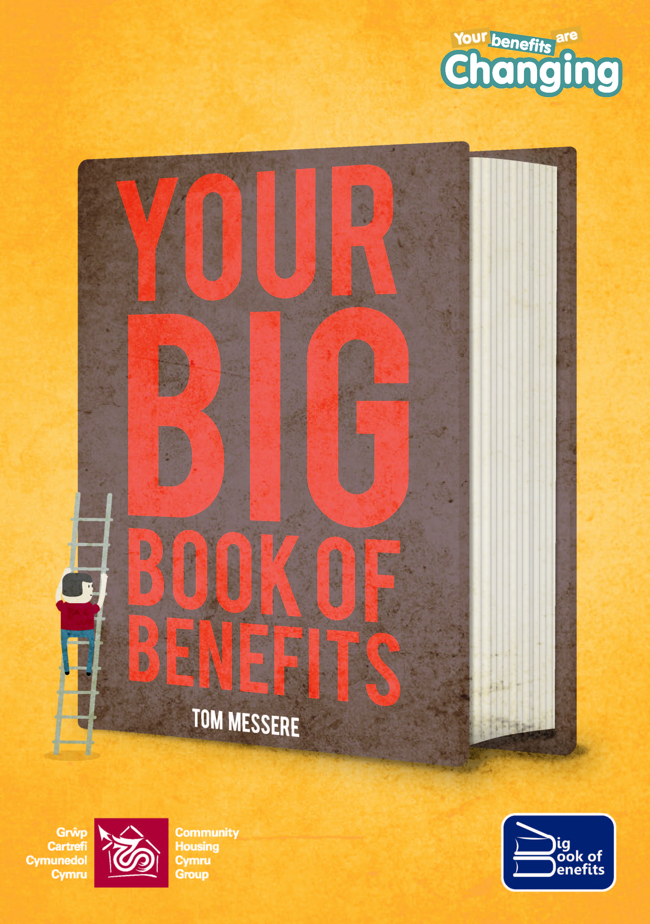
Contact name:
Address:

Contact telephone number:
You can also purchase stickers, balloons, badges, wristbands, fridge magnets, van wraps, beer mats and various leaflets branded with the Your Benefits are Changing logo. Please contact bethan-davies@chcymru.org.uk for a quote.
Please return your form to Bethan Davies at Community Housing Cymru, 2 Ocean Way, Cardiff, CF24 5TG. Alternatively, please email the form to bethan-davies@chcymru.org.uk
For CHC use only  Form processed | A/C number | Cheque attached & amount | Date passed to accounts

