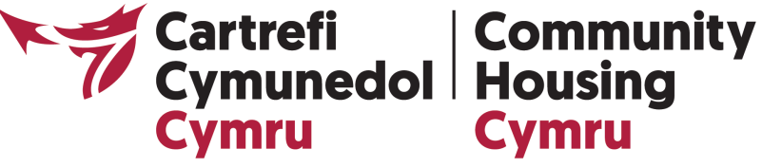

COURSE DETAILS:
New to Board
The course will cover:
Understanding housing associations
- What is a housing association: its role, purpose and regulatory framework
- Understanding the wider legislative and operating environment
- Money matters: running a sustainable organisation and ensuring value for money
Exploring the role of the Board
- The core functions of the Board: strategic leadership. Roles and responsibilities
- The 7 principles of good governance: understanding and applying the CHC code of governance
- Working with residents and other stakeholders: being accountable and working in partnership to drive positive outcomes for communities
Using your skills, knowledge and experience well
- Making meetings work: identifying the basics of good risk management, delegation
- and decision-making
- Monitoring organisational performance: how to ask the right questions to gain assurance
- Working together as a team: acting with integrity, managing conflicts and valuing diversity

