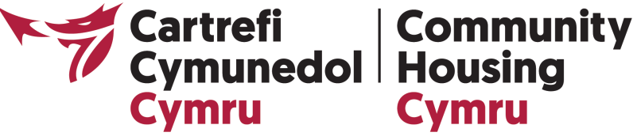

COURSE DETAILS:
An Introduction to Governance
The course will cover:
Understanding Governance
- Understanding the role of the Board
- ‘Governing’ vs ‘representing’ – the difference between the two and managing any conflicts
- Being effective and accountable – the key skills any Board members needs
Money Matters – Finance for “Non-finance People”
- How to run a financially sustainable and efficient organisation
- Maintaining effective financial control and probity
- Understanding and applying Value for Money principles
Managing Without Discrimination
- Living up to Equality & Diversity: what are the legal duties placed on organisations today?
- Why is it important to understand other perspectives?
- When and where could we exceed the legal minimum requirements?
Understanding Risk
- What is risk?
- Where do our key risks come from?
- What are the principles of good risk management?
Monitoring Performance
- Understanding performance indicators
- Asking the right questions and using information to make good decisions
- Understanding “the big picture” rather than monitoring day-to-day operations
Making Meetings Work
- Getting the most out of meetings and developing your communication skills
- Working as a team – managing relationships, diverse views and conflicts
- Balancing the need for openness and confidentiality

