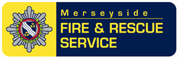

MFRS Information Note
INFORMATION:
The Liverpool FRS prevention team have come across a means of heating which could present a risk of electrocution to both the occupants and any visitors to the property. The enclosed picture shows a large metal can filled with water then two cables powered from a telephone socket wrapped around some sort of homemade element to heat the water in the can and thereby create a means of heating a room (a homemade radiator).
The voltage passing through the cables from the telephone socket ranges between 20 – 50 milliamps which could give a significant electrical shock should a person come into contact with the water in the can or the cables.
The resident was Polish and stated that this was a common practise across his country and other eastern European countries despite having a gas central heating system fitted in his property.

