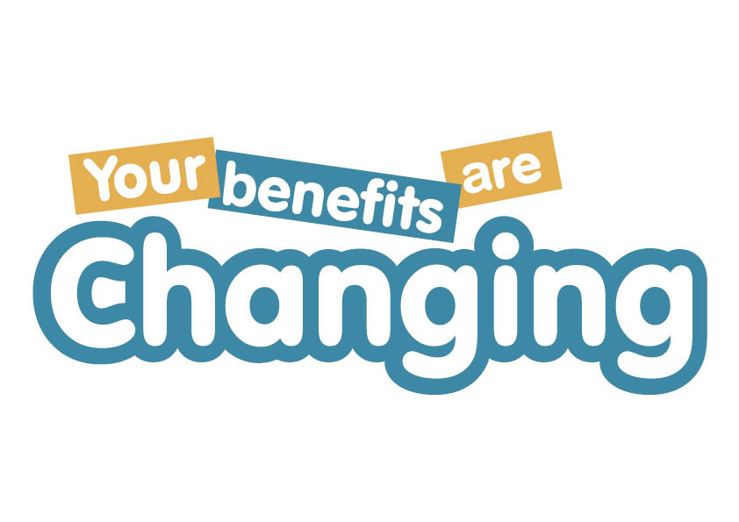
In-house enquiry form
My Benefits, Our Benefits, Your Benefits … are changing!
Date of enquiry

Organisation Name
Contact Name
Job Title
E-mail
Telephone No:

We would like to request in-house delivery of the following: Tick as Appropriate ✓
My Benefits are Changing
This session will provide a basic understanding of the main principles of Universal Credit and will cover how these changes may impact your staff, their families and their community. At CHC, we recognise that around half of our own employees will personally be affected by Universal Credit and believe that the sector will see a similar level across your own staff.
Who: All staff
Duration: 2 hours
Campaign Material: Editable poster template - ‘Universal Credit is coming and it’s not just going to affect tenants!’

Our Benefits are Changing
This session will involve selected staff from across your organisation to develop an understanding of how, as a sector, our benefits are changing. Using information gained from early pilots, demonstration projects and areas where UC is live, this session will help departments to understand how their own roles will evolve and what they will need to consider in order to make informed choices, including the consideration of new operational methods. The YBAC advisers will work with your welfare reform leads to tailor this session for your organisation.

Who: Smaller working groups of staff across specific departments.
Duration: 4 hours
Campaign Material: Editable poster template - ‘UC is coming and it will have an impact on all departments’

Your Benefits are Changing
The YBAC advice team has attended over 50 of your events, assisting you to communicate and inform your tenants about the changes. If you would like hands-on support for your events, why not book an adviser for the day?

Who: Tenants
Duration: ½ or full day (depending on location of event)
Campaign Material: New UC leaflet including check list of documentation needed to make a claim, and a poster template to promote your event.

Please return completed enquiry form to:-
Jennifer-horton@chcymru.org.uk
Jennifer Horton
Learning & Events Officer

Community Housing Cymru Group
2 Ocean Way, Cardiff, CF24 5TG

 029 2067 4809

