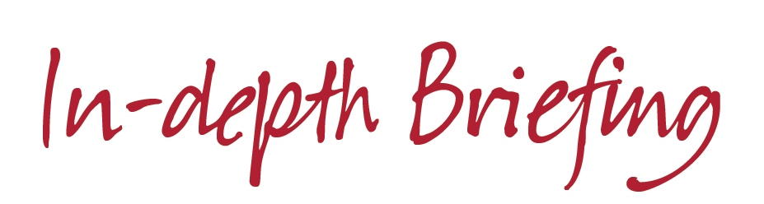
The EU Referendum and Housing Associations in Wales – Post Referendum

Background

In a referendum on Thursday 23rd June 2016, the United Kingdom voted to leave the European Union by a margin of 51.9% to 48.1%, on a turnout of 72.2%. The results of the constituent parts of the UK were as follows:

Nation | Leave (%) | Remain (%) | Turnout (%)
WALES | 52.5 | 47.5 | 71.7%
England | 53.4 | 46.6 | 73.0%
Scotland | 38.0 | 62.0 | 67.2%
Northern Ireland | 44.2 | 55.8 | 62.7%

What happens next?

The United Kingdom currently remains a member of the European Union, and will do until the UK Government invokes ‘Article 50’ – the process in EU treaties for withdrawing from the Union. It should be noted that the referendum result is not binding on the UK Government and was an advisory vote, and the timescales for triggering the Article 50 process remains unclear.

Once Article 50 is triggered, the UK and the EU will begin negotiations on a new relationship on a range of issues, including trade, immigration and financial contributions.

The Political Outlook

Following the result of the referendum, there has been enormous political fallout across the UK. On 24th June, Prime Minister David Cameron announced his resignation, triggering a leadership contest in the Conservative Party. After an eventful few weeks and a leadership contest which started with five Conservative MPs, the Conservative Parliamentary Party selected two candidates to go to a vote of the party’s membership; Home Secretary Theresa May MP, and Energy Minister Andrea Leadsom MP. However, following the withdrawal of Ms. Leadsom on 11th July, Theresa May was confirmed as leader of the Conservative Party, and was confirmed as Prime Minister on Wednesday 13th July.

Alongside this, Labour Party leader Jeremy Corbyn has faced a challenge to his leadership over the result of the referendum. Following a vote of no confidence in his leadership by the Parliamentary Labour Party, it was confirmed on 11th July that former Business Minister Angela Eagle MP would be officially challenging him for the leadership.

Meanwhile, Nigel Farage has resigned as party leader of the UK Independence Party for the third time.

Scottish First Minister Nicola Sturgeon has indicated that she will seek to maintain a relationship between Scotland and the EU on the current terms of the UK’s agreement, and the vote to leave may trigger a second referendum on Scottish independence.

In Wales, First Minister Carwyn Jones has written to the Prime Minister asking him to confirm that the current round of EU funding due to Wales – around £1.9bn until 2020 – is safe. He has also suggested that the UK should consider federalism as a potential solution to the breakup of the UK, amid moves from Plaid Cymru to place Welsh independence on the agenda.

The Economic Outlook

The political fallout and the uncertainty over future trading arrangements have had a significant economic impact since the ‘Brexit’ vote.

- The £ immediately dropped from a high of $1.50 on the eve of the referendum results to around $1.34 and has continued to fall gradually to a current rate of $1.28, as of 11th July.
- Credit ratings agencies Standard & Poor and Fitch both downgraded the UK’s credit rating.
- Shares in banking and construction sectors have fallen sharply since 23rd June.
- Britain’s second biggest brick maker – Forterra – will mothball two of its plants, in Claughton and Accrington, due to the current economic uncertainty.

In response to these economic concerns, Chancellor George Osborne and Bank of England Governor Mark Carney have both promised to intervene by taking measures necessary to support the UK economy and stave off the risk of recession. Carney has suggested that the banks were in a stronger position to deal with the current economic concerns than before the 2008 financial crisis, following their recapitalisation and ongoing stress-testing. He has also indicated that officials could inject an additional £250bn into the system to ensure that financial institutions do not run short of cash. He confirmed that the Bank of England would consider a host of measures and policies to promote monetary and financial stability, including an interest rate cut and further quantitative easing. However, thus far, markets have responded negatively, with decreasing yields on Government bonds and gilts.

The Impact on Housing Associations

CHC’s pre-referendum briefing outlined some of the areas in which the referendum could impact upon the business of housing associations. While the UK remains a member of the EU, many of these will not change, including the free movement of goods and people under EU law. The long term future position in these areas will not become clear until after the UK triggers Article 50 and negotiates a new relationship with the EU. Overleaf, we have set out the current models the EU has with other states.

However, since the referendum, there has been clarity on some issues, including:

- EU Funding

Countries outside the EU – including those in the European Economic Area – do not have access to funding programmes such as the European Regional Development Fund. Existing contracts and funding will be honoured, but the position on contracts which were being negotiated remains unclear.

- The European Investment Bank (EIB)

EIB has invested approximately £5.5bn in social housing in the UK, and they have committed to honour all existing loans. The UK has a 16.11% shareholding in the bank as one of the four main shareholders, and in a statement following the referendum, the EIB said:

“At present the UK shareholding in the EIB remains and the EIB’s engagement in the UK is unchanged. Any change to the EIB’s shareholder structure or lending activity is a decision for the member states. We expect that the EIB’s shareholders, the 28 EU member states, will discuss the EIB’s engagement in the UK as part of broader discussions to define the future relationship of the UK with Europe and European bodies. At present, the EIB’s shareholders have not requested the Bank to change its approach to operations in the UK.”
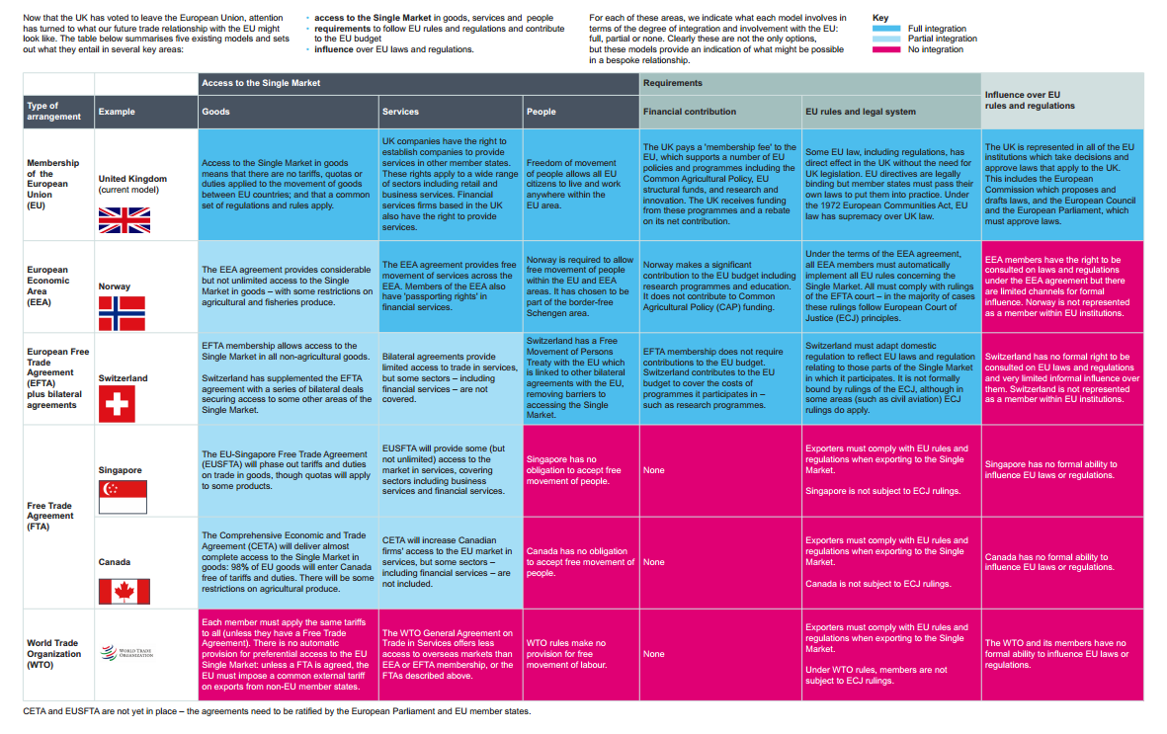

Other issues to consider

A number of issues remain for housing associations to consider, many of which may not become clear for some time.

- Building Materials

As highlighted in our pre-referendum briefing, the UK is a net importer of building material such as bricks from the EU. With free trade agreements still in place, the long term impact of the referendum result on the availability of building materials cannot be known until a new trade agreement is negotiated. However, in the short term, the decreasing value of the pound could lead to more expensive imports.

- House Prices & The Housing Market

In the run up to the referendum, Chancellor George Osborne warned of a crash in house prices by as much as 18% by 2018, and the Halifax’s Chief Economist warned of an underlying slowdown in the market prior to the referendum due to the uncertainty caused.

The impact will become clear over the coming months, but any further slowdown, allied with the sharp decrease in the shares of construction companies, is likely to have a severe impact on the confidence of lenders, and ultimately, house building.

Housing associations should also consider the long term impact of any changes in migration policy. The number of EU migrants accessing social housing is relatively small, but any changes in the residency rights of EU migrants in the UK, and vice versa, could have an impact upon the demography of the UK as a whole.

- Community Cohesion

Throughout the referendum campaign and since the announcement of the result, there have been many reports of rising tensions between those who voted to leave and remain, and a worrying increase in reports of hate crimes toward EU and non-EU migrants. The National Police Chiefs’ Council has reported a 57% increase in the aftermath of the referendum.

This is something housing associations should be aware of in the communities in which they operate. Community Housing Cymru has been approached by Diverse Cymru – a charity campaigning against discrimination and inequality – who is working across Welsh civil society to develop a robust response to this. If you would like further information on this, please contact CHC directly.

What is CHC doing?

Community Housing Cymru is continuing to monitor the uncertain environment caused by the result of the European Union Referendum.

This briefing answers a number of questions we have received since the result on 24th June, but the impact on a huge range of areas remains uncertain. We will continue to work with the UK Government and , in particular, Welsh Government to understand the impact ‘Brexit’ will have on Welsh public services and on current and future EU funding programmes that will affect housing associations.

With the confirmation of the new Prime Minister this week, the Article 50 process and negotiations over a new deal between the EU and the UK will likely move a step closer. We will continue to keep you informed of further developments.

Community Housing Cymru
July 2016

